

**Instituto Politécnico Nacional**

**ESCOM “Escuela Superior de Cómputo”**

INGENIERÍA EN SISTEMAS COMPUTACIONALES

*Análisis Fundamental de Circuitos*

*Práctica 2*

Profesor: Figueroa Del Prado Felipe De Jesus

ALUMNO:

Rojas Alvarado Luis Enrique

Grupo: 1CM6

INDEX

**Objective1**

Material1

Equipment1

**Theorist Introduction1**

Equivalent resistor2

Experimental progress2

Calculations3

Circuit simulations4

Circuit simulations varying the voltage4

Circuit simulations varying the resistance13

Comparative of calculated, measured and simulated values23

Voltage dependent circuit24

Resistance dependent ciruit26

Questionary28

Inferences28

Bibliography29

# Objective

The student will understand and handle the proper interpretation of Ohm's law, so that at the end of the practice, he will be able to: calculate the voltages, currents, powers and resistances of a circuit. Understand the behavior of the current with respect to voltage. Understand the behavior of the current with respect to the resistance. Deduce Ohm's law.

# Material

* Breadboard
* 4 points banana-cayman
* 2 points cayman-cayman
* 1K Ohm resistor (1/4 watt)
* 1 Ohm resistor (1 watt)
* 2.5K Ohm potentiometer

# Equipment

* Digital multimeter
* Variable voltage source
* C. A.

# Theorist introduction

Ohm's Law is a basic theory to explain how electricity behaves. For this we must know three concepts. Current, Voltage and Resistance. The relationship between these concepts is the so-called Ohm's law.

The definition of these concepts is:

* Intensity: It is the circulation of electrons that goes from one point to another. Its unit of measurement are the amps.
* 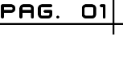Voltage: It is the force that leaves the electrons can have movement through the conductive material. Its unit of measurement are volts.
* Resistance: It is the obstruction that occurs to electrons inside a conduit. Its unit of measurement are the ohms.

Ohm's law says that the current that flows through a conductor of electricity is directly supplied to the voltage variation and parallel and inversely to the resistance. Its importance is because in a circuit you can know beforehand how it will work before connecting. Taking into account the information of two of the three elements that are handled. The formulas to know in advance how your circuit will work are the following:

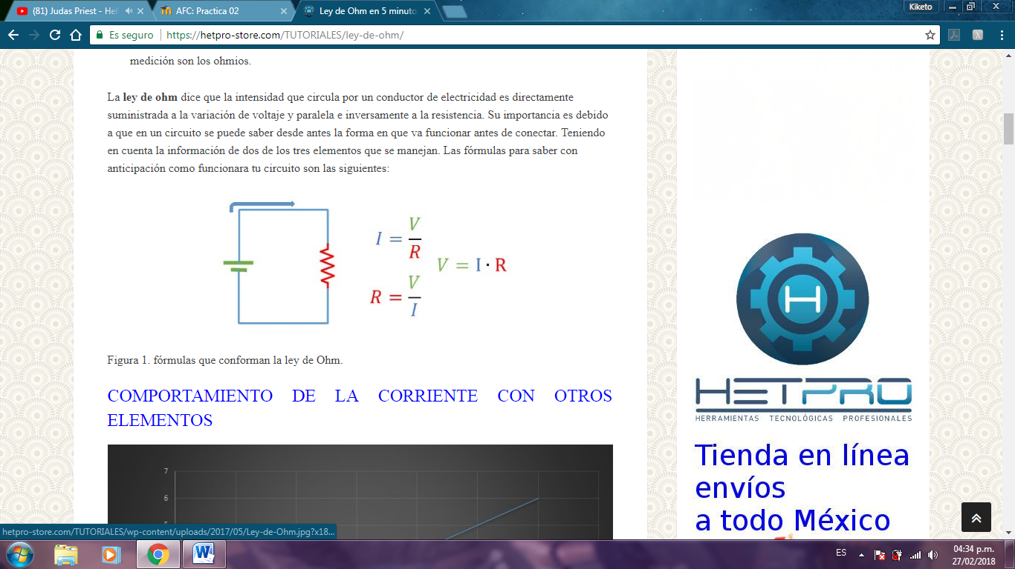

## Equivalent resistor

The resistance has a wide range of quantities, which have different colors and that is what determines the value of ohms in the resistor.

Resistance is an option to have control over the current and cause a voltage drop. The form of connection in which the resistors are placed can change the value (in series or parallel).

If one wants to obtain the equivalent resistance of 3 resistors, it would suffice to add the resistors.

# Experimental progress

To start the practice it was necessary to put the potentiometer at a fixed value of 2.5kΩ by measuring it with the ohmmeter. Next, the voltage source, the potentiometer and a 1kΩ resistor were connected.

Having the armed circuit began to vary the voltage source from 0V to 15V and measured the current that passes through the circuit connecting in series with the ammeter from the source to the potentiometer. The current values obtained by the ammeter were recorded in a plane in which a graph that ascends with each voltage value will be seen.

Subsequently, using the same circuit and having the ammeter connected in series, the source will be set at a fixed value of 15V, the ohmmeter will be connected from the potentiometer to the end of the 1kΩ resistor.

The total resistance and current of the circuit will be calculated only by varying the potentiometer from 0Ω to 2.5Ω, the values that the ammeter and ohmmeter throw will be shown in a graph.

Then a circuit was armed only with the voltage source at 1V, the ammeter in series and the resistance of 1kΩ and the power of the circuit was calculated.

# Calculations

To calculate the current flowing through the first circuit Ohm's law was used:

First all the resistors are added since it is a series circuit:

Then to obtain the intensity of the circuit it is necessary to clear the intensity of the formula:

# Circuit simulations

## Circuit simulations varying the voltage

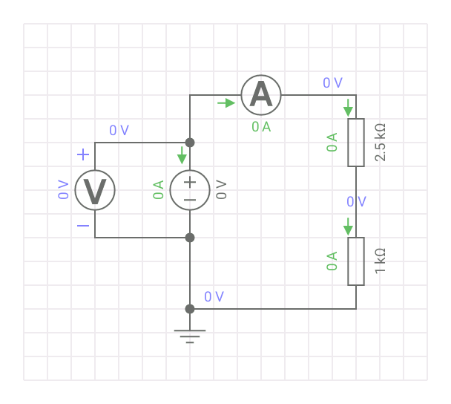

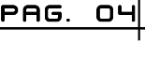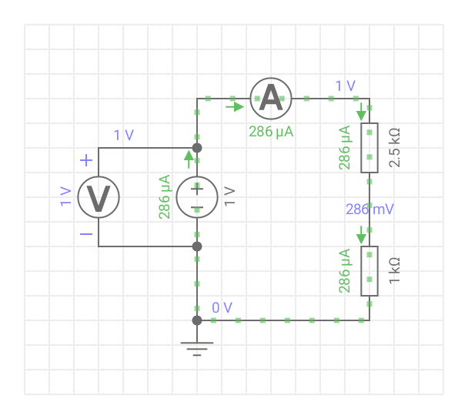

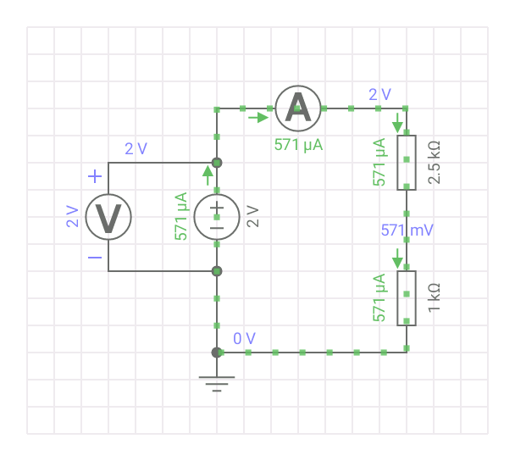

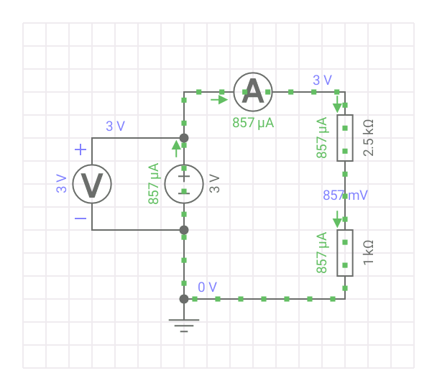

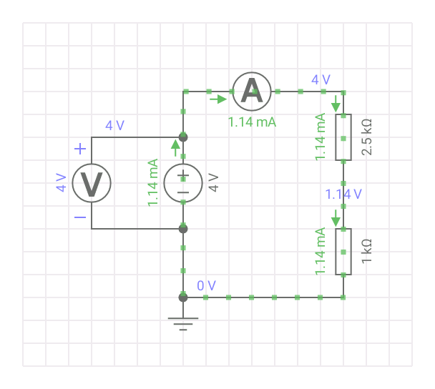

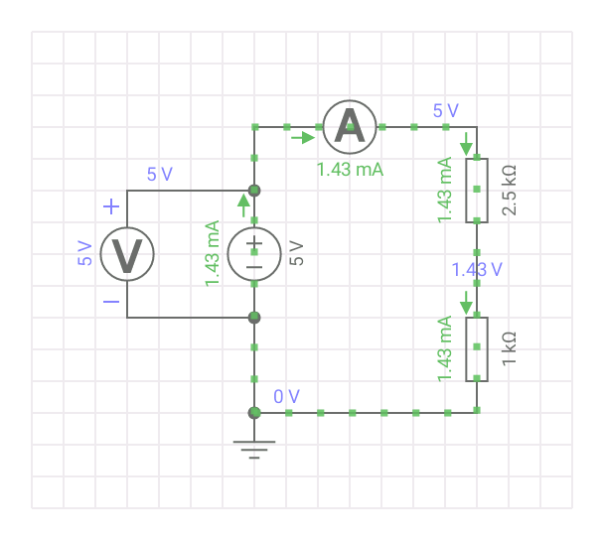



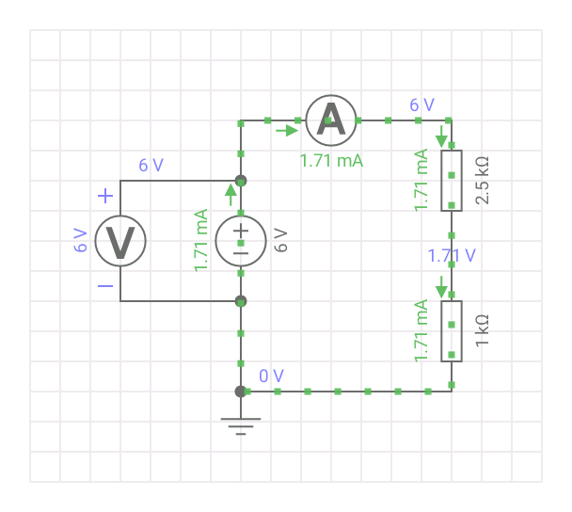

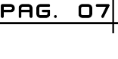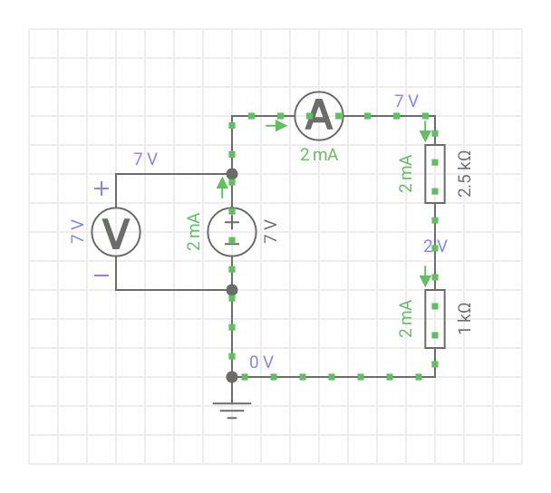

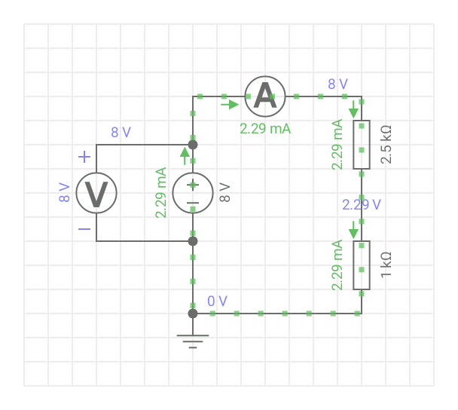

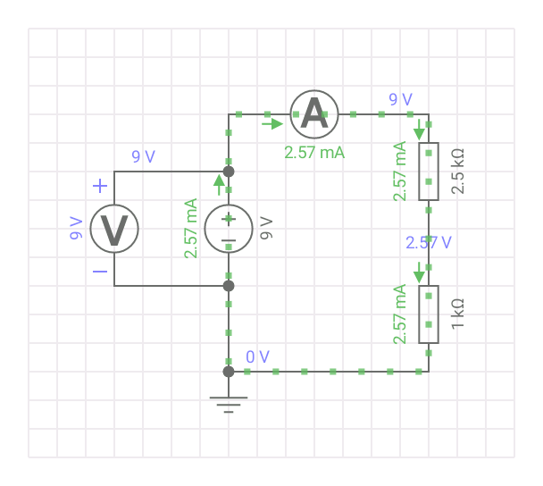



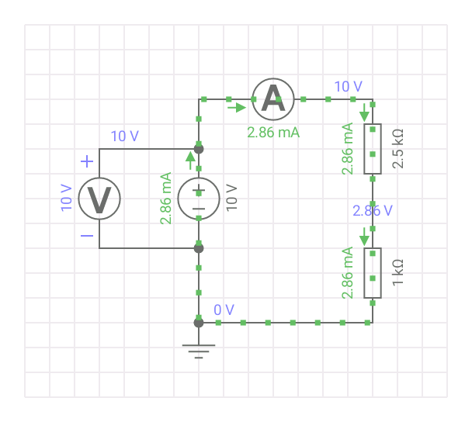

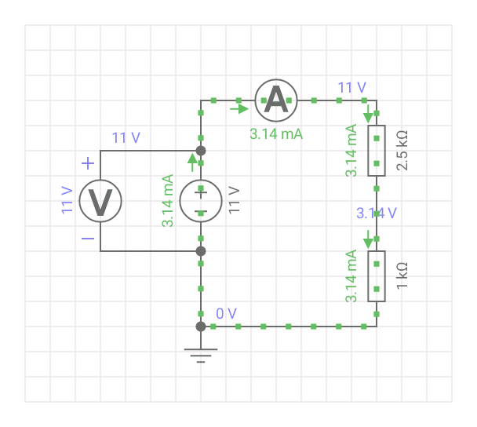

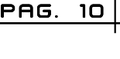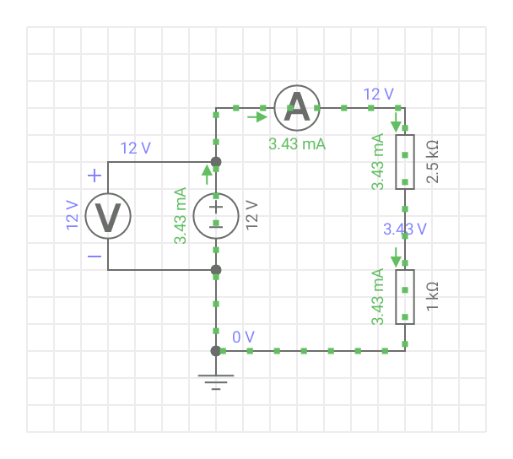

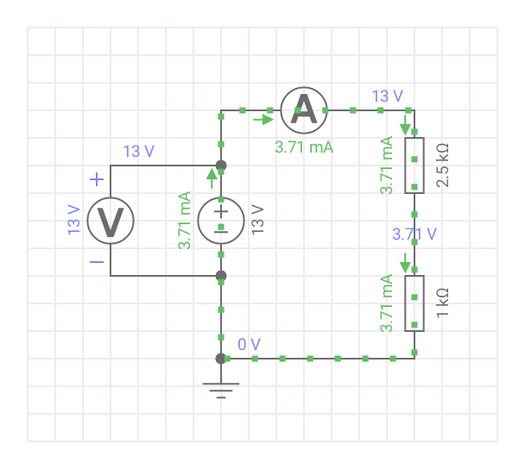

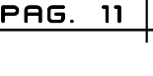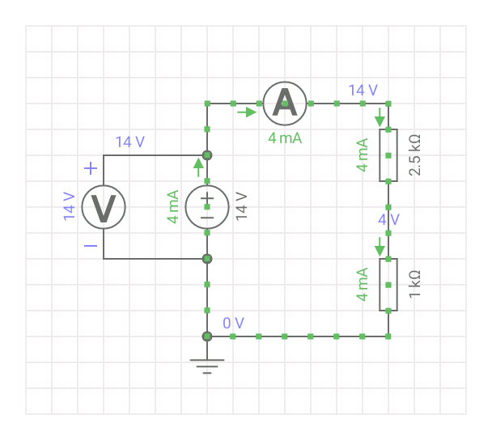

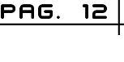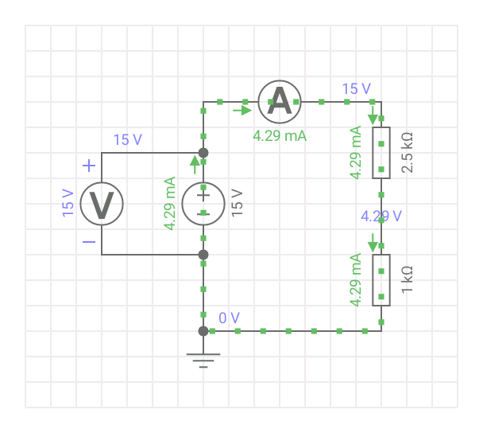

## Circuit simulations varying the resistance

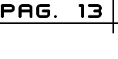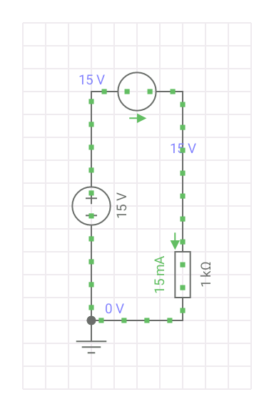

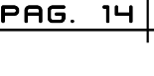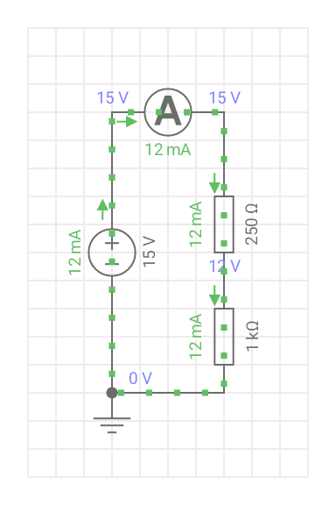

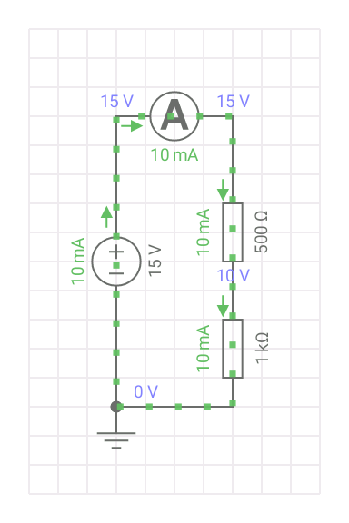



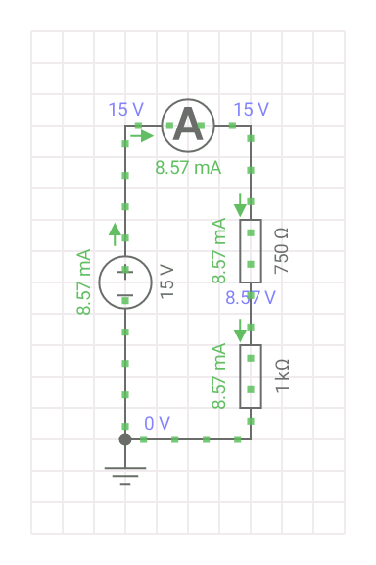

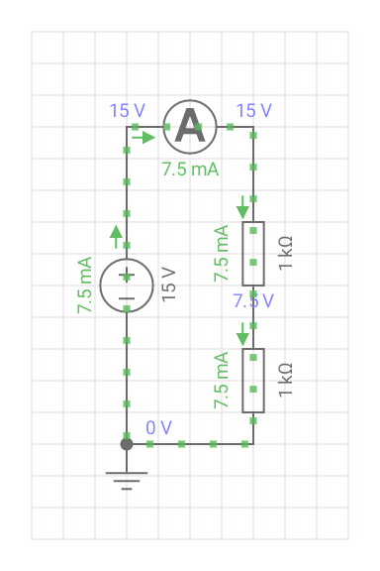

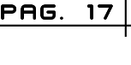

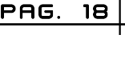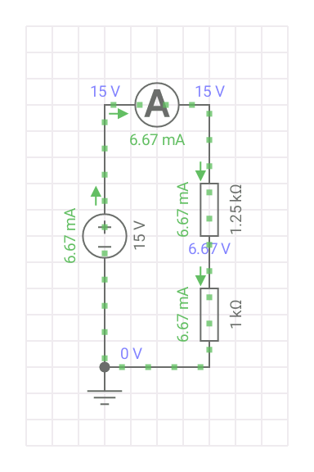

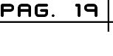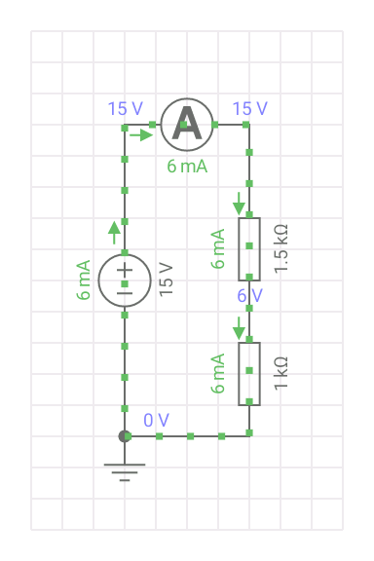

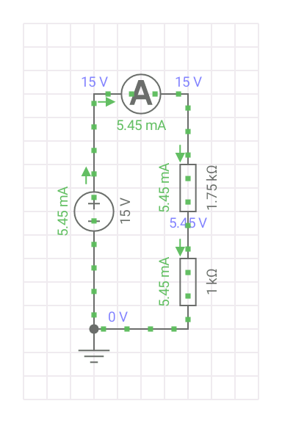

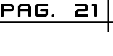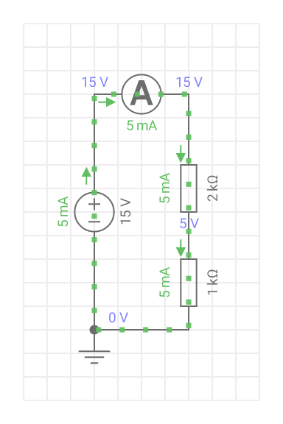

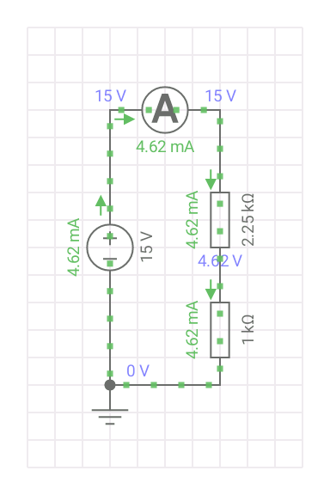

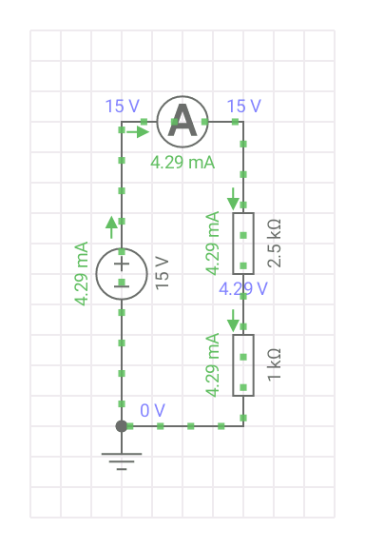

# Comparative of calculated, measured and simulated values

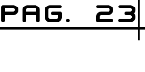

## Voltage dependent circuit

|  |  |  |  |
| --- | --- | --- | --- |
| Voltage source | Measured values | Calculated values | Simulated values |
| 0V | 0 | 0 | 0 |
| 1V | 275 µA | 285 µA | 286 µA |
| 2V | 561 µA | 571 µA | 571 µA |
| 3V | 845 µA | 857 µA | 857 µA |
| 4V | 1.09 mA | 1.14 mA | 1.14 mA |
| 5V | 1.35 mA | 1.42 mA | 1.43 mA |
| 6V | 1.61 mA | 1.71 mA | 1.71 mA |
| 7V | 1.89 mA | 2 mA | 2 mA |
| 8V | 2.22 mA | 2.28 mA | 2.29 mA |
| 9V | 2.51 mA | 2.57 mA | 2.57 mA |
| 10V | 2.78 mA | 2.86 mA | 2.86 mA |
| 11V | 3.09 mA | 3.14 mA | 3.14 mA |
| 12V | 3.36 mA | 3.42 mA | 3.43 mA |
| 13V | 3.64 mA | 3.71 mA | 3.71 mA |
| 14V | 3.91 mA | 4 mA | 4 mA |
| 15V | 4.2 mA | 4.28 mA | 4.29 mA |

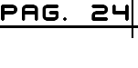



## Resistance dependent circuit

|  |  |  |  |  |
| --- | --- | --- | --- | --- |
| Potentiometer | Total resistance | Current measurement | Current calculated | Current simulated |
| 0 Ω | 1000 Ω | 14.8 mA | 15 mA | 15 mA |
| 250 Ω | 1250 Ω | 12.08 mA | 12 mA | 12 mA |
| 500 Ω | 1500 Ω | 9.88 mA | 10 mA | 10 mA |
| 750 Ω | 1750 Ω | 8.5 mA | 8.57 mA | 8.57 mA |
| 1000 Ω | 2000 Ω | 7.8 mA | 7.5 mA | 7.5 mA |
| 1250 Ω | 2250 Ω | 6.62 mA | 6.6 mA | 6.67 mA |
| 1500 Ω | 2500 Ω | 5.94 mA | 6 mA | 6 mA |
| 1750 Ω | 2750 Ω | 5.49 mA | 5.45 mA | 5.45 mA |
| 2000 Ω | 3000 Ω | 4.88 mA | 5 mA | 5 mA |
| 2250 Ω | 3250 Ω | 4.5 mA | 4.61 mA | 4.62 mA |
| 2500 Ω | 3500 Ω | 4.17 mA | 4.28 mA | 4.29 mA |



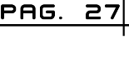

# Questionary

1. What is the electrical current value?
   1. 0.98 mA
2. What is the value of the power that the resistance dissipates?
   1. 96 mW
3. What effect happened on the resistance?
   1. Did not have any physical effect
4. Why?
   1. There is no excess voltage that damages it

Again assemble the previous circuit, but now using the resistance of 1Ω to 1 watt, before connecting the voltage source make sure it is fixed at 1 volt and that the ammeter is on the same scale.

1. What is the electrical current value?
   1. 166 mA
2. What is the value of the power that the resistance dissipates?
   1. 2.75 W
3. What effect happened on the resistance?
   1. Did not have any physical effect
4. What is the difference with the previous circuit?
   1. The resistor dissipates more power
5. Why?
   1. As the resistance is lower, the power increases

# Inferences

## Inference of Luis Enrique Rojas Alvarado

When making the measurements with the potentiometer and the resistance we realized that to make the calculations it was necessary to reduce to an equivalent circuit making the approximate measurements coincide with the multimeter and the calculations. As we recovered the data in the tables we realized the law of ohm is fulfilled if we know how to apply it.

## Inference of Aldo Hassan Rodríguez Hernández

Making the calculations was quite simple since Ohm's law makes the work much easier, the biggest problem was measuring the current in each circuit that depended on the resistance since it was difficult to change the resistance of the potentiometer

## Inference of Rubén Abiasaf Quintana Camacho

The practice did not have much difficulty since you only had to apply Ohm's law to obtain the requested values

# Bibliography

* <https://hetpro-store.com/TUTORIALES/ley-de-ohm/>